Need the informations to change the text on the front page. You still didn’t send me the source code.

***Professional Front desk :***

1) When we open the website, need to create 2 options:

-one option for private clients as it is already (already made)

- create a second option for Professional clients.

- need to create a new page & link for professional clients, with only the Personal Information with 2 Languages [Eng & French ]

On this professional page, they have to put their personal informations. – 10 hrs

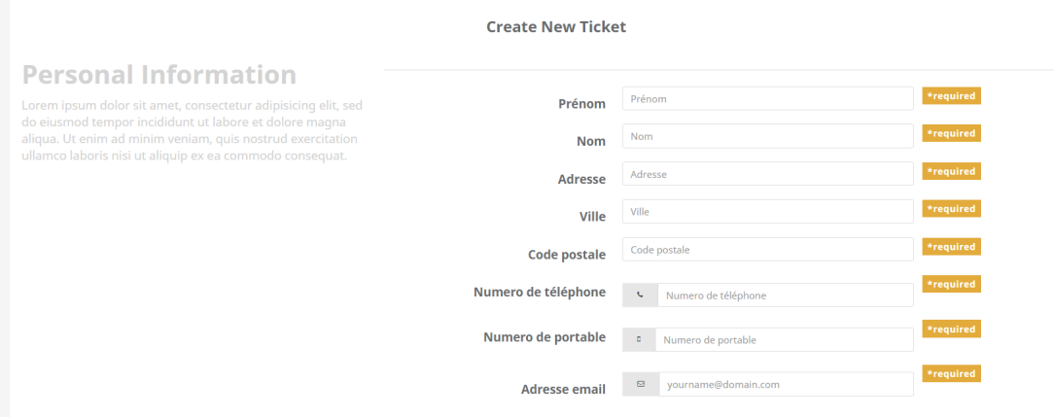

But, Need to create a button where they can download a sample excel file where they have to fill all the informations about the defective phones and create an upload button to load the excel file and register all the informations automatically in the database. – 30 hrs

This option will allow them to register a batch of phones instead of doing it one by one.

-

2) On the professional page, need to add an option to order spare parts. Since some of our professional client repair their phones by themselves, they need spare parts to fix them

I’ll create a list of spare parts, the client will have to select the iphone model and the quantity, and I’ll get their order to send them.

– 20 hrs

If you need Data entry For the spare part with 2 language – 6 hrs

3) Need to add a pop-up to confirm that the ticket as been validated when the clients finishes to register all his informations. – 2 hrs

- Successful registration will be shown on a pop up

4) As discussed before, I want to edit a PDF file where I get all the informations the client registred. Even something like a screenshot of the page is fine for me. – 10 hrs

- You Need PDF or A Page ? Editing a PDF will cost☺, I will give a page for display

- this will lead a new dash board

***Dash board:***

Need to create filters, to filter tickets according to the status.

Need to add an option to get reports, where I can know how many defective phones I got in a selected period, the quantity per model, the quantity per problem (defective phone, defective network etc), the quantity per selling platform. Actually I need to filter and get a report per information registred. – 15 hrs

* This will give you a web page, and download to excel

***IMEI database:***

We register in excel files all the IMEI numbers of the phones we buy and we sell. Sometimes, clients are trying to cheat us, they ask us to repaird their phone even if they bought it from an other shop. I want to create a database where I upload all our IMEI numbers, and when the client will register his phone, I want to know if the phone is from us or not. –10 hrs

***Details to fix:***

On the personalinformation form, need to delete the phone number. No need to ask 2 phones numbers, 1 is enough.

On the ticket page, need to add a box where to add the tracking number when we ship back the phone to the client when the phone is repaired.

Need to have 2 languages for the home page, French/English. So need to add a button to change the language. – 10 hrs

Nearly ~ 95 -110 hrs